Course Code: CSE316 Course Title: Operating System
Report

School of Computer Science and Engineering Faculty of Technology And Sciences
Name of the faculty member : Vasudha

Student Name: Sai Tanish Madana
Student ID: 11710923
Section: K17UK
Email Address: kedar.tanish@gmail.com
GitHub Link:
https://github.com/SaiTanish/OS-Project

Ques. 20. Consider that a system has P resources of same type. These resources are shared by Q processes time to time. All processes request and release the resources one at a time. Generate a solution to demonstrate that, the system is in safe state when following conditions are satisfied.
Conditions:
a.) Maximum resource need of each process is between 1 and P. b.) Summation of all maximum needs is less than P+Q

Code:
//* Assigning max resources required for each process
*// condition 1.max resources is between 1, p
//*Given that condition 2. smax<p+q *//
//*Generating test cases which satisfies both conditions*//

Description:
Proof:
Suppose
N = Sum of all Need(i),
A = Sum of all Allocation(i),
M = Sum of all Max(i).
Use contradiction to prove.
Assume this system is not deadlock free. If there exists a deadlock state, then
A = p because there's only one kind of resource and resources can be requested and released only one at a time. From condition b, N + A = M < p + q. So we get N + p < p + q. So we get N < q. It shows that at least one process i that Need(i) = 0. From condition a, Pi can release at least 1 resource. So there are q-1 processes sharing p resources now, condition a and b still hold.
Go on the argument, no process will wait permanently, so there's no deadlock.

Also Using banker's algorithm you'll see that one process will acquire all needed resources and after completion of work it will release resources hence no deadlock will occur.

Algorithm:

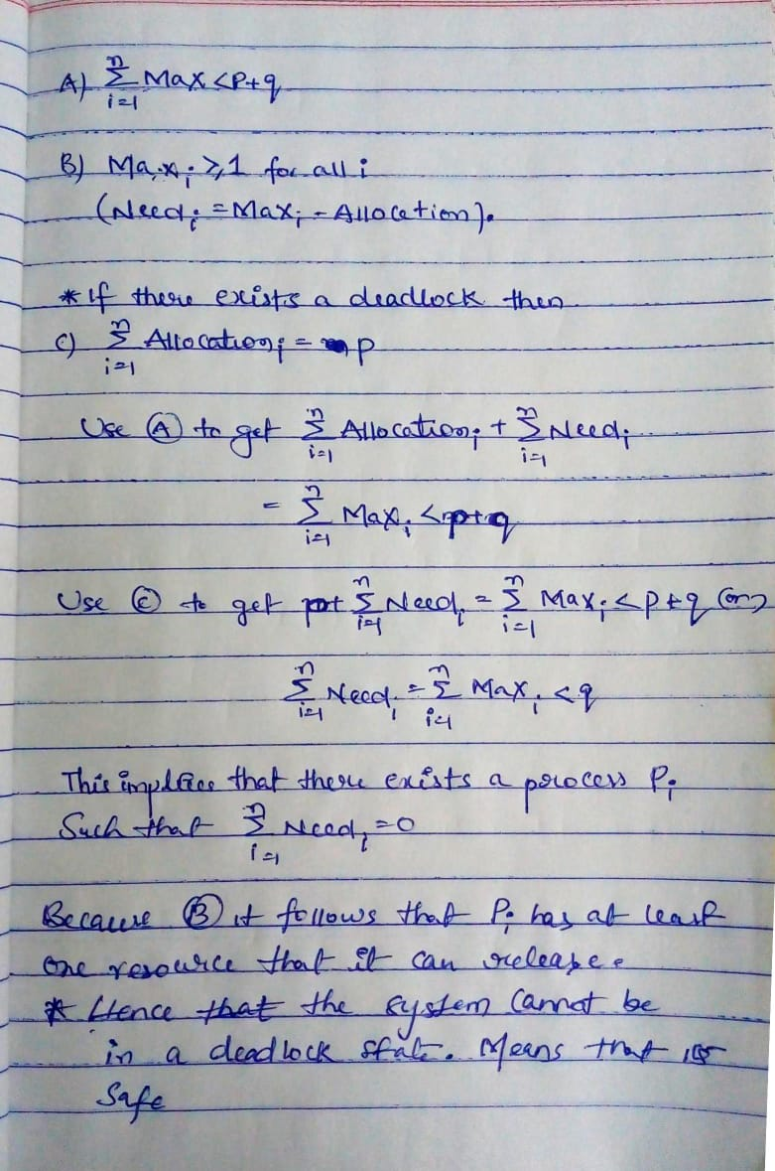

Worst Complexity Case:

Consider the worst case- all processes acquire maximum resources but still not able to finish. So, the resources available must be 1 less than than the maximum need, for each of the processes (this ensures none of them can finish).
We are given maximum need is always less than p + q. As per our condition for deadlock, resources available must be 1 less than maximum need for each of 'q' processes => totally the resources available must be less than p + q - p = q.
But 'p' is the available number of resources and hence no deadlock can occur.

Constraints given in the problem:

The following conditions should be satisfied
a. The maximum need of each process is between one resource and p resources.

If the system is assumed to not be deadlock free and there exists a deadlock state, then A=M because there is only one resource which can be requested/released one at a time.

b. The sum of all maximum needs is less than p+ q.

In this condition, M < p+q = N+A, which is the same as N+p< p+q so N < q. From condition a, this process n release at least one resource, so there are q-1 processes sharing q resources at this point, and both conditions a and b still hold true. No processes will wait permanently so there is no deadlock.

Algorithm’s used:
To show that the safe state in the question we have used 2 algorithms which are
1.Banker’s Algorithm
2.Safe State Algorithm

